Documentación Prueba Técnica

**Kushki**

|  |  |  |  |  |  |
| --- | --- | --- | --- | --- | --- |
| **CONTROL DE VERSIONES** | | | | | |
| **VERSIÓN** | **FECHA** | **CAMBIO** | **PREPARADO POR** | **REVISADO POR** | **APROBADO POR** |
| 1.0 | 25/08/2021 | Creación del documento | Manuel Torres |  |  |

Tabla de contenidos

Introducción 1

Información del proyecto 1

Configuración del Back-End 2

Información de la prueba 2

Request a suscription Token 2

Create a Suscription 4

Create a Pre-Authorize Payment 5

Capture a Pre-Authorize Payment 7

Get Suscription Info 9

Void a Transaction 11

Get Transactions List 13

Experiencia de Onboarding con Kushki, Oportunidades de mejoras identificadas. 37

Experiencia con la documentacion técnica, Oportunidades de mejoras identificadas y propuestas de mejora de las mismas. 37

Que entiendes por el concepto de tokenización y por qué cree que se recomienda tokenizar por medio de una solución front-end. 38

Que entiendes por el concepto de webhook y cual es su utilidad. 38

Consideraciones 38

# Introducción

Para este proyecto se ha realizado dos desarrollos, el primero es para el front-end, esta realizado en html y javascript puro que la función que tiene es llamar a la cajita de pagos implementada por Kushki y el segundo desarrollo es para la parte de back-end, esta realizado en nodeJs con express para consumir los servicios indicados.

# Información del proyecto

El proyecto fue desarrollado y es ejecutado con las siguientes características.

|  |  |  |  |
| --- | --- | --- | --- |
| **Característica** | | **Valor** | **URL Descarga / Funcionamiento** |
| 1 | Front-End | Html y javascript | https://maserrot-kushki.000webhostapp.com/ |
| 2 | Back-End | NodeJs, Express | https://github.com/maserrot/kushki_completo |

# Configuración del Back-End

Para configurar el proyecto en un NodeJs son necesarios los siguientes pasos:

1. Descargar el proyecto back-kushki del Git indicado.
2. Ingresar en el proyecto.
3. Instalar las dependencias con el comando “**npm install**”
4. Ejecutar el servidor con el comando “**node index.js**”
5. Realizar las pruebas con los request eniados.

# Información de la prueba

## Request a suscription Token

Para lo cual se implemento la cajita de pagos de kushki en una página HTML con javascript, y se muestra de la siguiente forma:

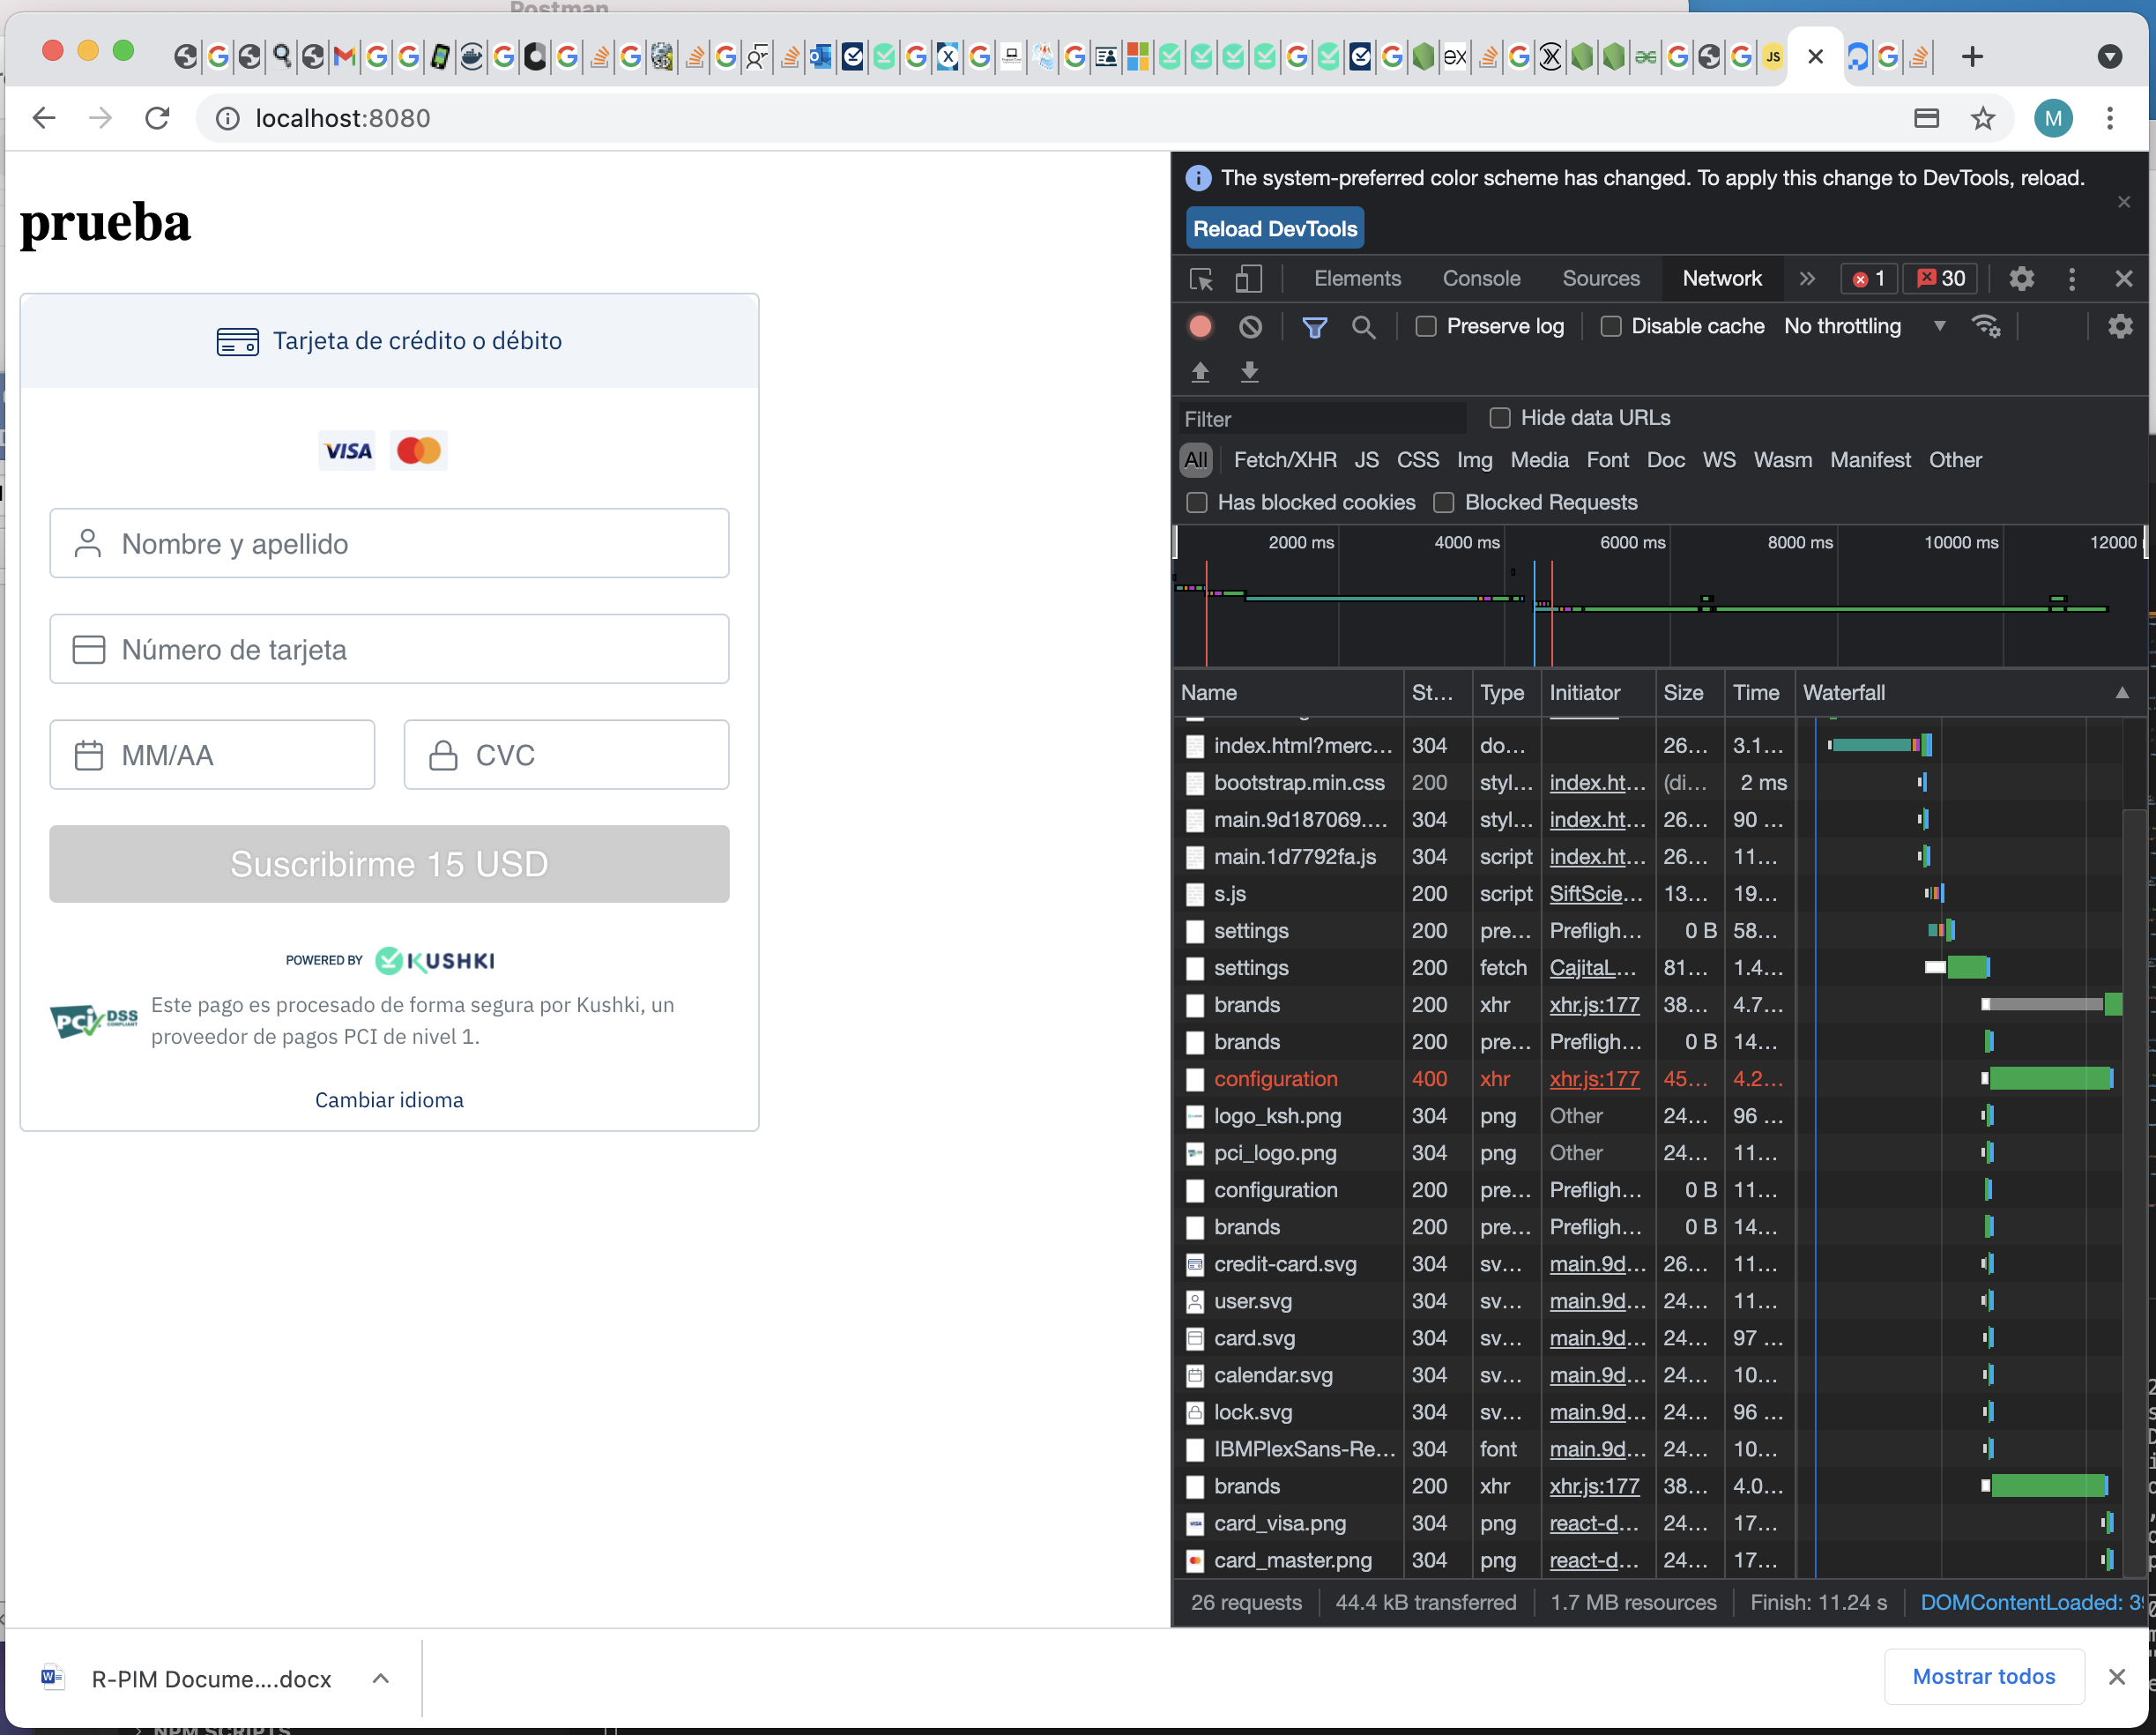

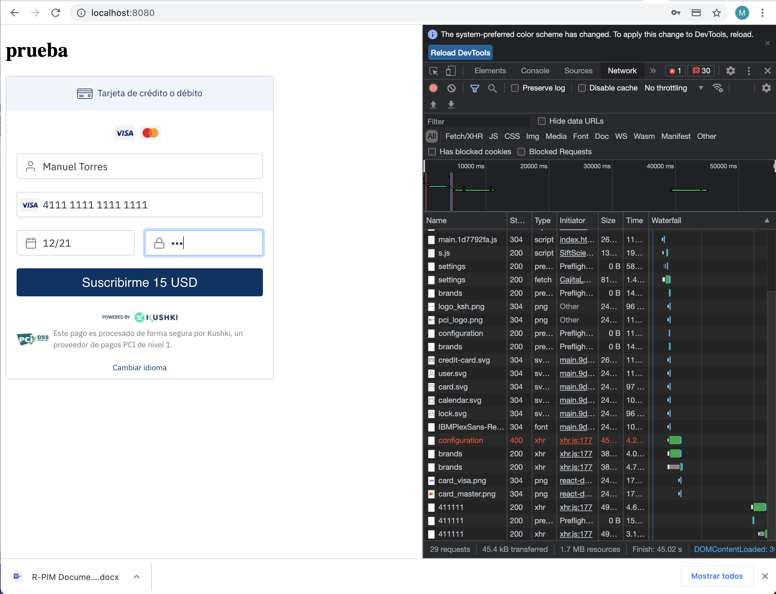

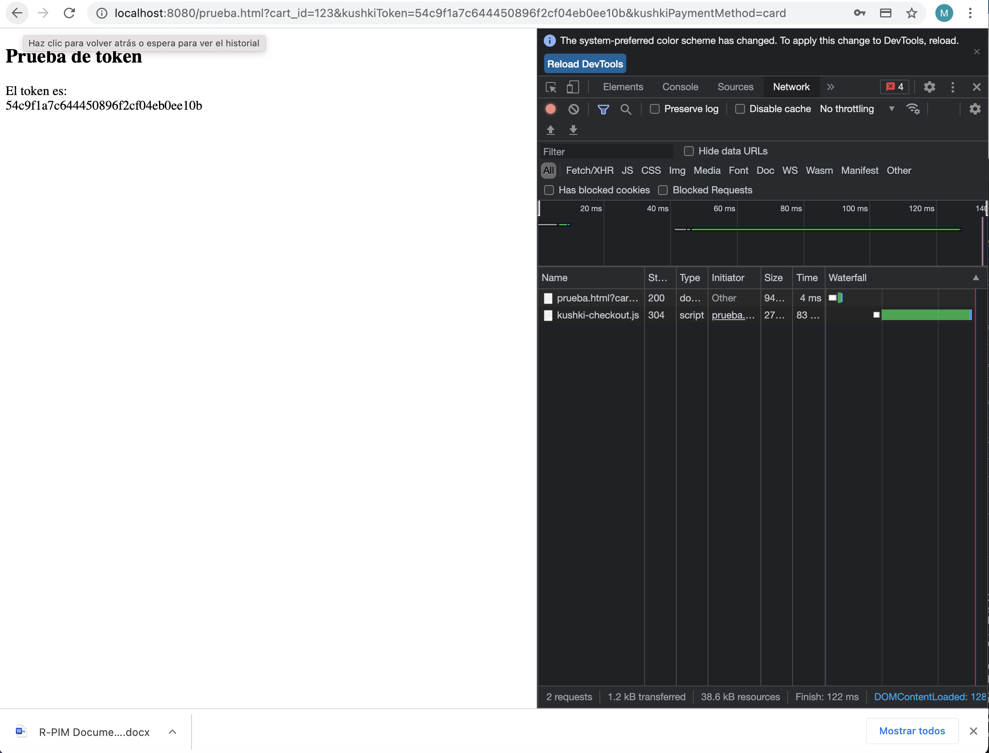

Con el token obtenido se realiza las siguientes preguntas.

El token es 54c9f1a7c644450896f2cf04eb0ee10b

## Create a Suscription

Para lo cual se implemento el back-end con nodeJs y express, para consumir el servicio se lo realizo por postman y se obtiene los siguientes resultados.

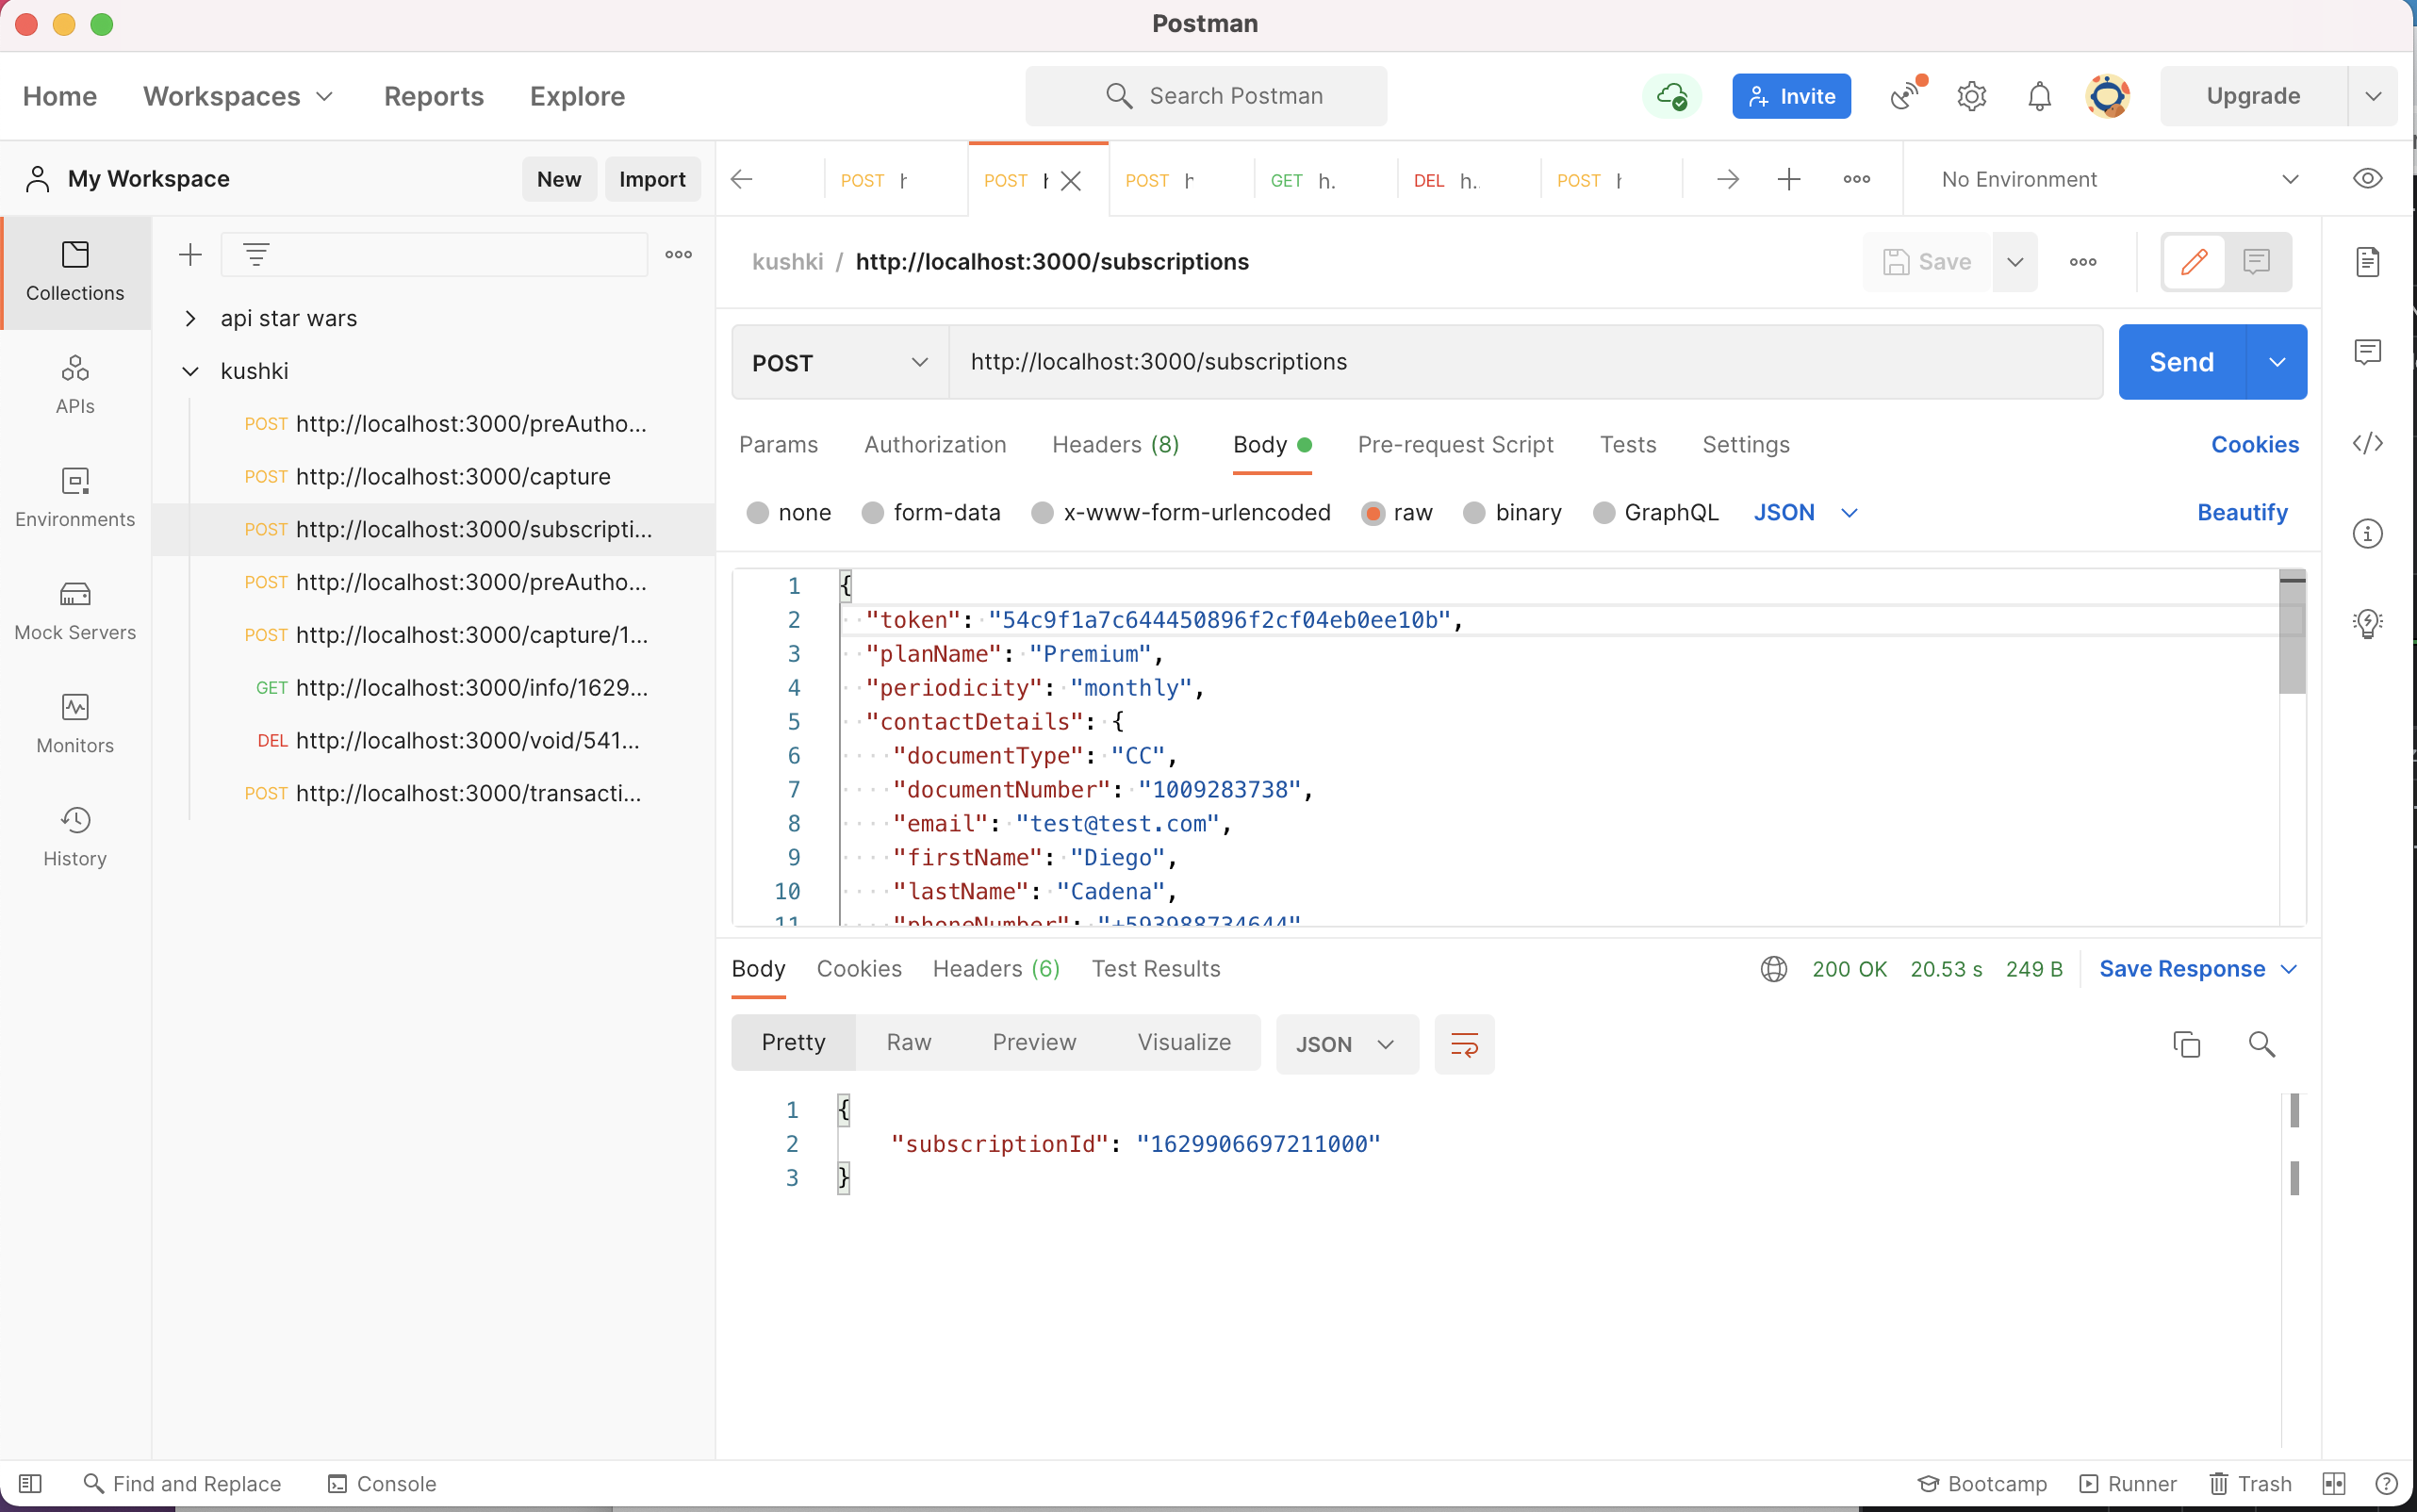

|  |  |
| --- | --- |
| **Tipo** | **Descripción** |
| URL | http://localhost:3000/subscriptions |
| Tipo | REST |
| Método | POST |
| Request | {  "token": "54c9f1a7c644450896f2cf04eb0ee10b",  "planName": "Premium",  "periodicity": "monthly",  "contactDetails": {  "documentType": "CC",  "documentNumber": "1009283738",  "email": "test@test.com",  "firstName": "Diego",  "lastName": "Cadena",  "phoneNumber": "+593988734644"  },  "amount": {  "subtotalIva": 15,  "subtotalIva0": 0,  "ice": 0,  "iva": 0,  "currency": "USD"  },  "startDate": "2021-08-23",  "metadata": {  "plan": {  "fitness": {  "cardio": "include",  "rumba": "include",  "pool": "include"  }  }  }  } |
| Response | {  "subscriptionId": "1629906697211000"  } |

## Create a Pre-Authorize Payment

Para lo cual se implemento el back-end con nodeJs y express, para consumir el servicio se lo realizo por postman y se obtiene los siguientes resultados.

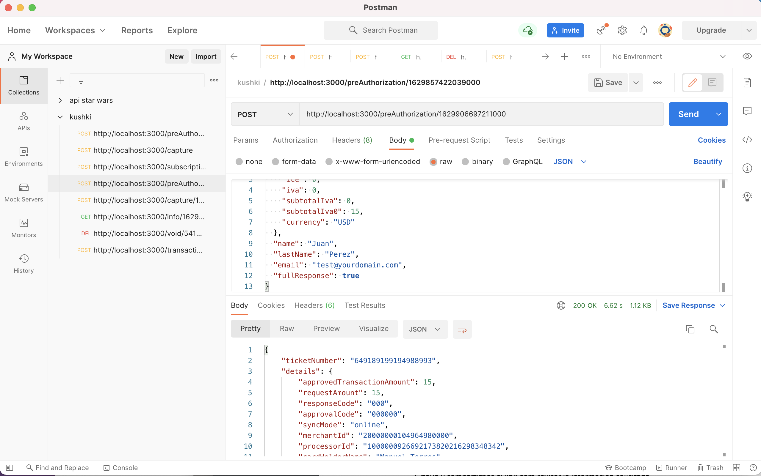

|  |  |
| --- | --- |
| **Tipo** | **Descripción** |
| URL | http://localhost:3000/preAuthorization/1629906697211000 |
| Tipo | REST |
| Método | POST |
| Request | {  "amount": {  "ice": 0,  "iva": 0,  "subtotalIva": 0,  "subtotalIva0": 15,  "currency": "USD"  },  "name": "Juan",  "lastName": "Perez",  "email": "test@yourdomain.com",  "fullResponse": **true**  } |
| Response | {  "ticketNumber": "649189199194988993",  "details": {  "approvedTransactionAmount": 15,  "requestAmount": 15,  "responseCode": "000",  "approvalCode": "000000",  "syncMode": "online",  "merchantId": "20000000104964980000",  "processorId": "1000000926692173820216298348342",  "cardHolderName": "Manuel Torres",  "binCard": "411111",  "merchantName": "maserrot",  "processorName": "Datafast Processor",  "processorBankName": "0032~BANCO INTERNACIONAL",  "transactionId": "464083956044158961",  "lastFourDigits": "1111",  "binInfo": {  "bank": "JPMORGAN CHASE BANK, N.A.",  "type": "credit"  },  "paymentBrand": "VISA",  "subtotalIva": 0,  "subtotalIva0": 15,  "currencyCode": "USD",  "ivaValue": 0,  "cardCountry": "United States of America",  "created": 1629906697,  "fullResponse": **true**,  "transactionStatus": "APPROVAL",  "transactionType": "PREAUTHORIZATION",  "transactionReference": "55513951-5f93-4e4b-8892-f2a0848d37d4",  "acquirerBank": "Banco peru",  "rules": []  },  "transactionReference": "55513951-5f93-4e4b-8892-f2a0848d37d4"  } |

## Capture a Pre-Authorize Payment

Para lo cual se implemento el back-end con nodeJs y express, para consumir el servicio se lo realizo por postman y se obtiene los siguientes resultados.

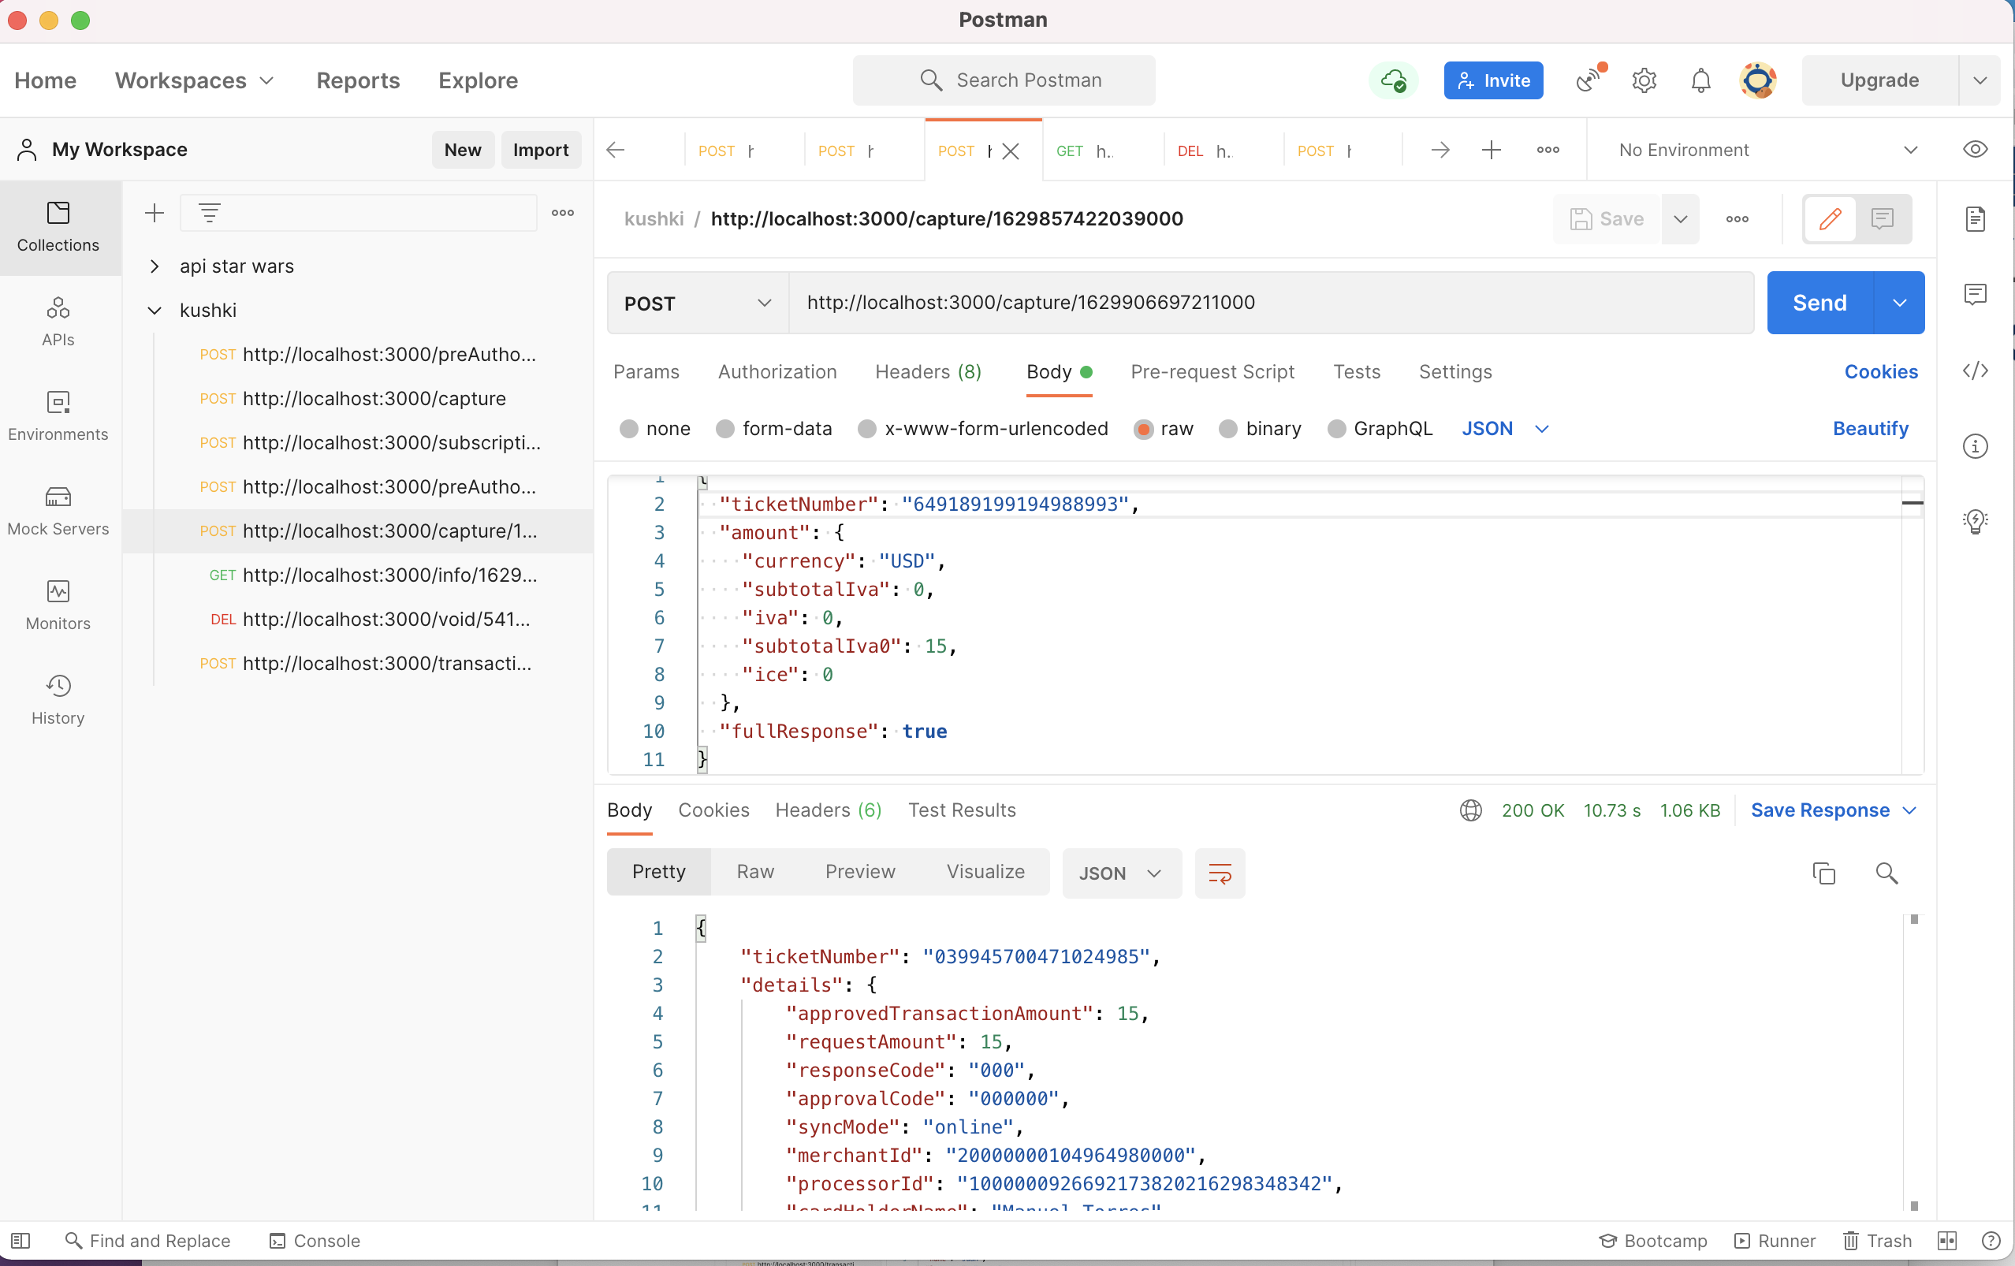

|  |  |
| --- | --- |
| **Tipo** | **Descripción** |
| URL | http://localhost:3000/capture/1629906697211000 |
| Tipo | REST |
| Método | POST |
| Request | {  "ticketNumber": "649189199194988993",  "amount": {  "currency": "USD",  "subtotalIva": 0,  "iva": 0,  "subtotalIva0": 15,  "ice": 0  },  "fullResponse": **true**  } |
| Response | {  "ticketNumber": "039945700471024985",  "details": {  "approvedTransactionAmount": 15,  "requestAmount": 15,  "responseCode": "000",  "approvalCode": "000000",  "syncMode": "online",  "merchantId": "20000000104964980000",  "processorId": "1000000926692173820216298348342",  "cardHolderName": "Manuel Torres",  "binCard": "411111",  "processorName": "Datafast Processor",  "processorBankName": "",  "transactionId": "186883766161297715",  "lastFourDigits": "1111",  "binInfo": {  "bank": "JPMORGAN CHASE BANK, N.A.",  "type": "credit"  },  "paymentBrand": "VISA",  "subtotalIva": 0,  "subtotalIva0": 15,  "currencyCode": "USD",  "ivaValue": 0,  "cardCountry": "United States of America",  "created": 1629906697,  "fullResponse": **true**,  "transactionStatus": "APPROVAL",  "transactionType": "CAPTURE",  "preauthTransactionReference": "55513951-5f93-4e4b-8892-f2a0848d37d4",  "acquirerBank": "Banco peru"  },  "transactionReference": "713de06b-9820-4398-a9bd-78e39a1e94c6"  } |

## Get Suscription Info

Para lo cual se implemento el back-end con nodeJs y express, para consumir el servicio se lo realizo por postman y se obtiene los siguientes resultados.

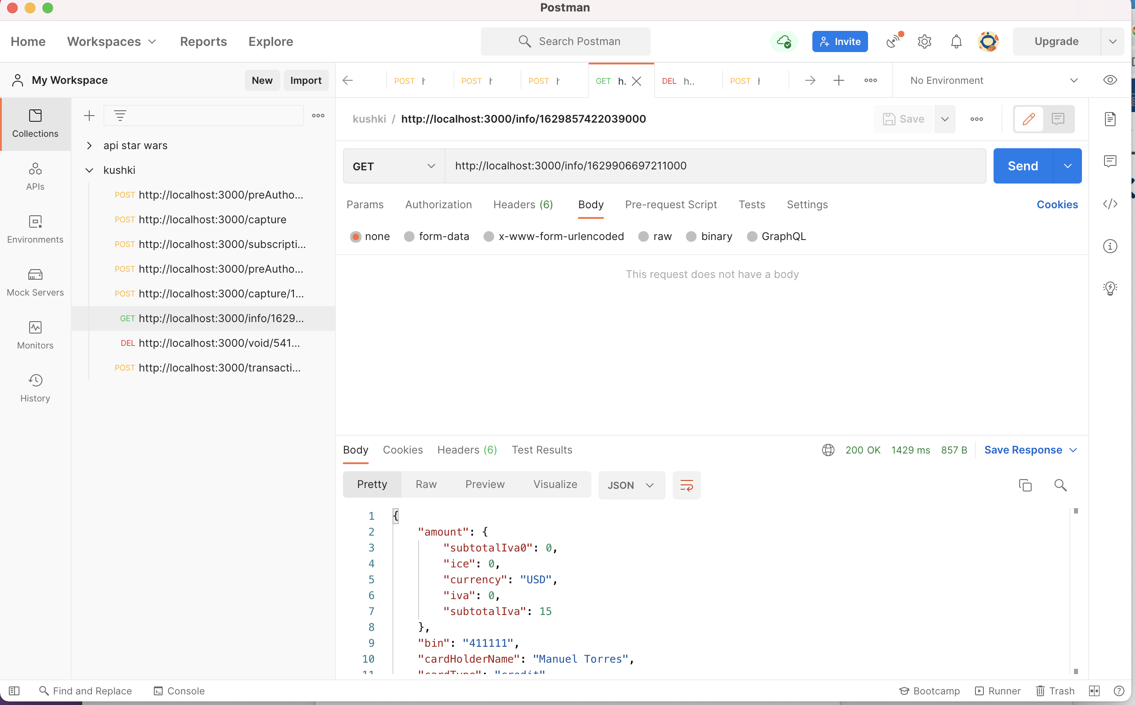

|  |  |
| --- | --- |
| **Tipo** | **Descripción** |
| URL | http://localhost:3000/info/1629906697211000 |
| Tipo | REST |
| Método | GET |
| Request |  |
| Response | {  "amount": {  "subtotalIva0": 0,  "ice": 0,  "currency": "USD",  "iva": 0,  "subtotalIva": 15  },  "bin": "411111",  "cardHolderName": "Manuel Torres",  "cardType": "credit",  "contactDetails": {  "firstName": "Diego",  "lastName": "Cadena",  "phoneNumber": "+593988734644",  "documentType": "CC",  "documentNumber": "1009283738",  "email": "test@test.com"  },  "created": 1629906697,  "lastFourDigits": "1111",  "maskedCardNumber": "411111XXXXXX1111",  "merchantId": "20000000104964980000",  "metadata": {  "plan": {  "fitness": {  "rumba": "include",  "pool": "include",  "cardio": "include"  }  }  },  "paymentBrand": "VISA",  "periodicity": "monthly",  "planName": "Premium",  "startDate": 1629676800,  "subscriptionId": "1629906697211000"  } |

## Void a Transaction

Para lo cual se implemento el back-end con nodeJs y express, para consumir el servicio se lo realizo por postman y se obtiene los siguientes resultados.

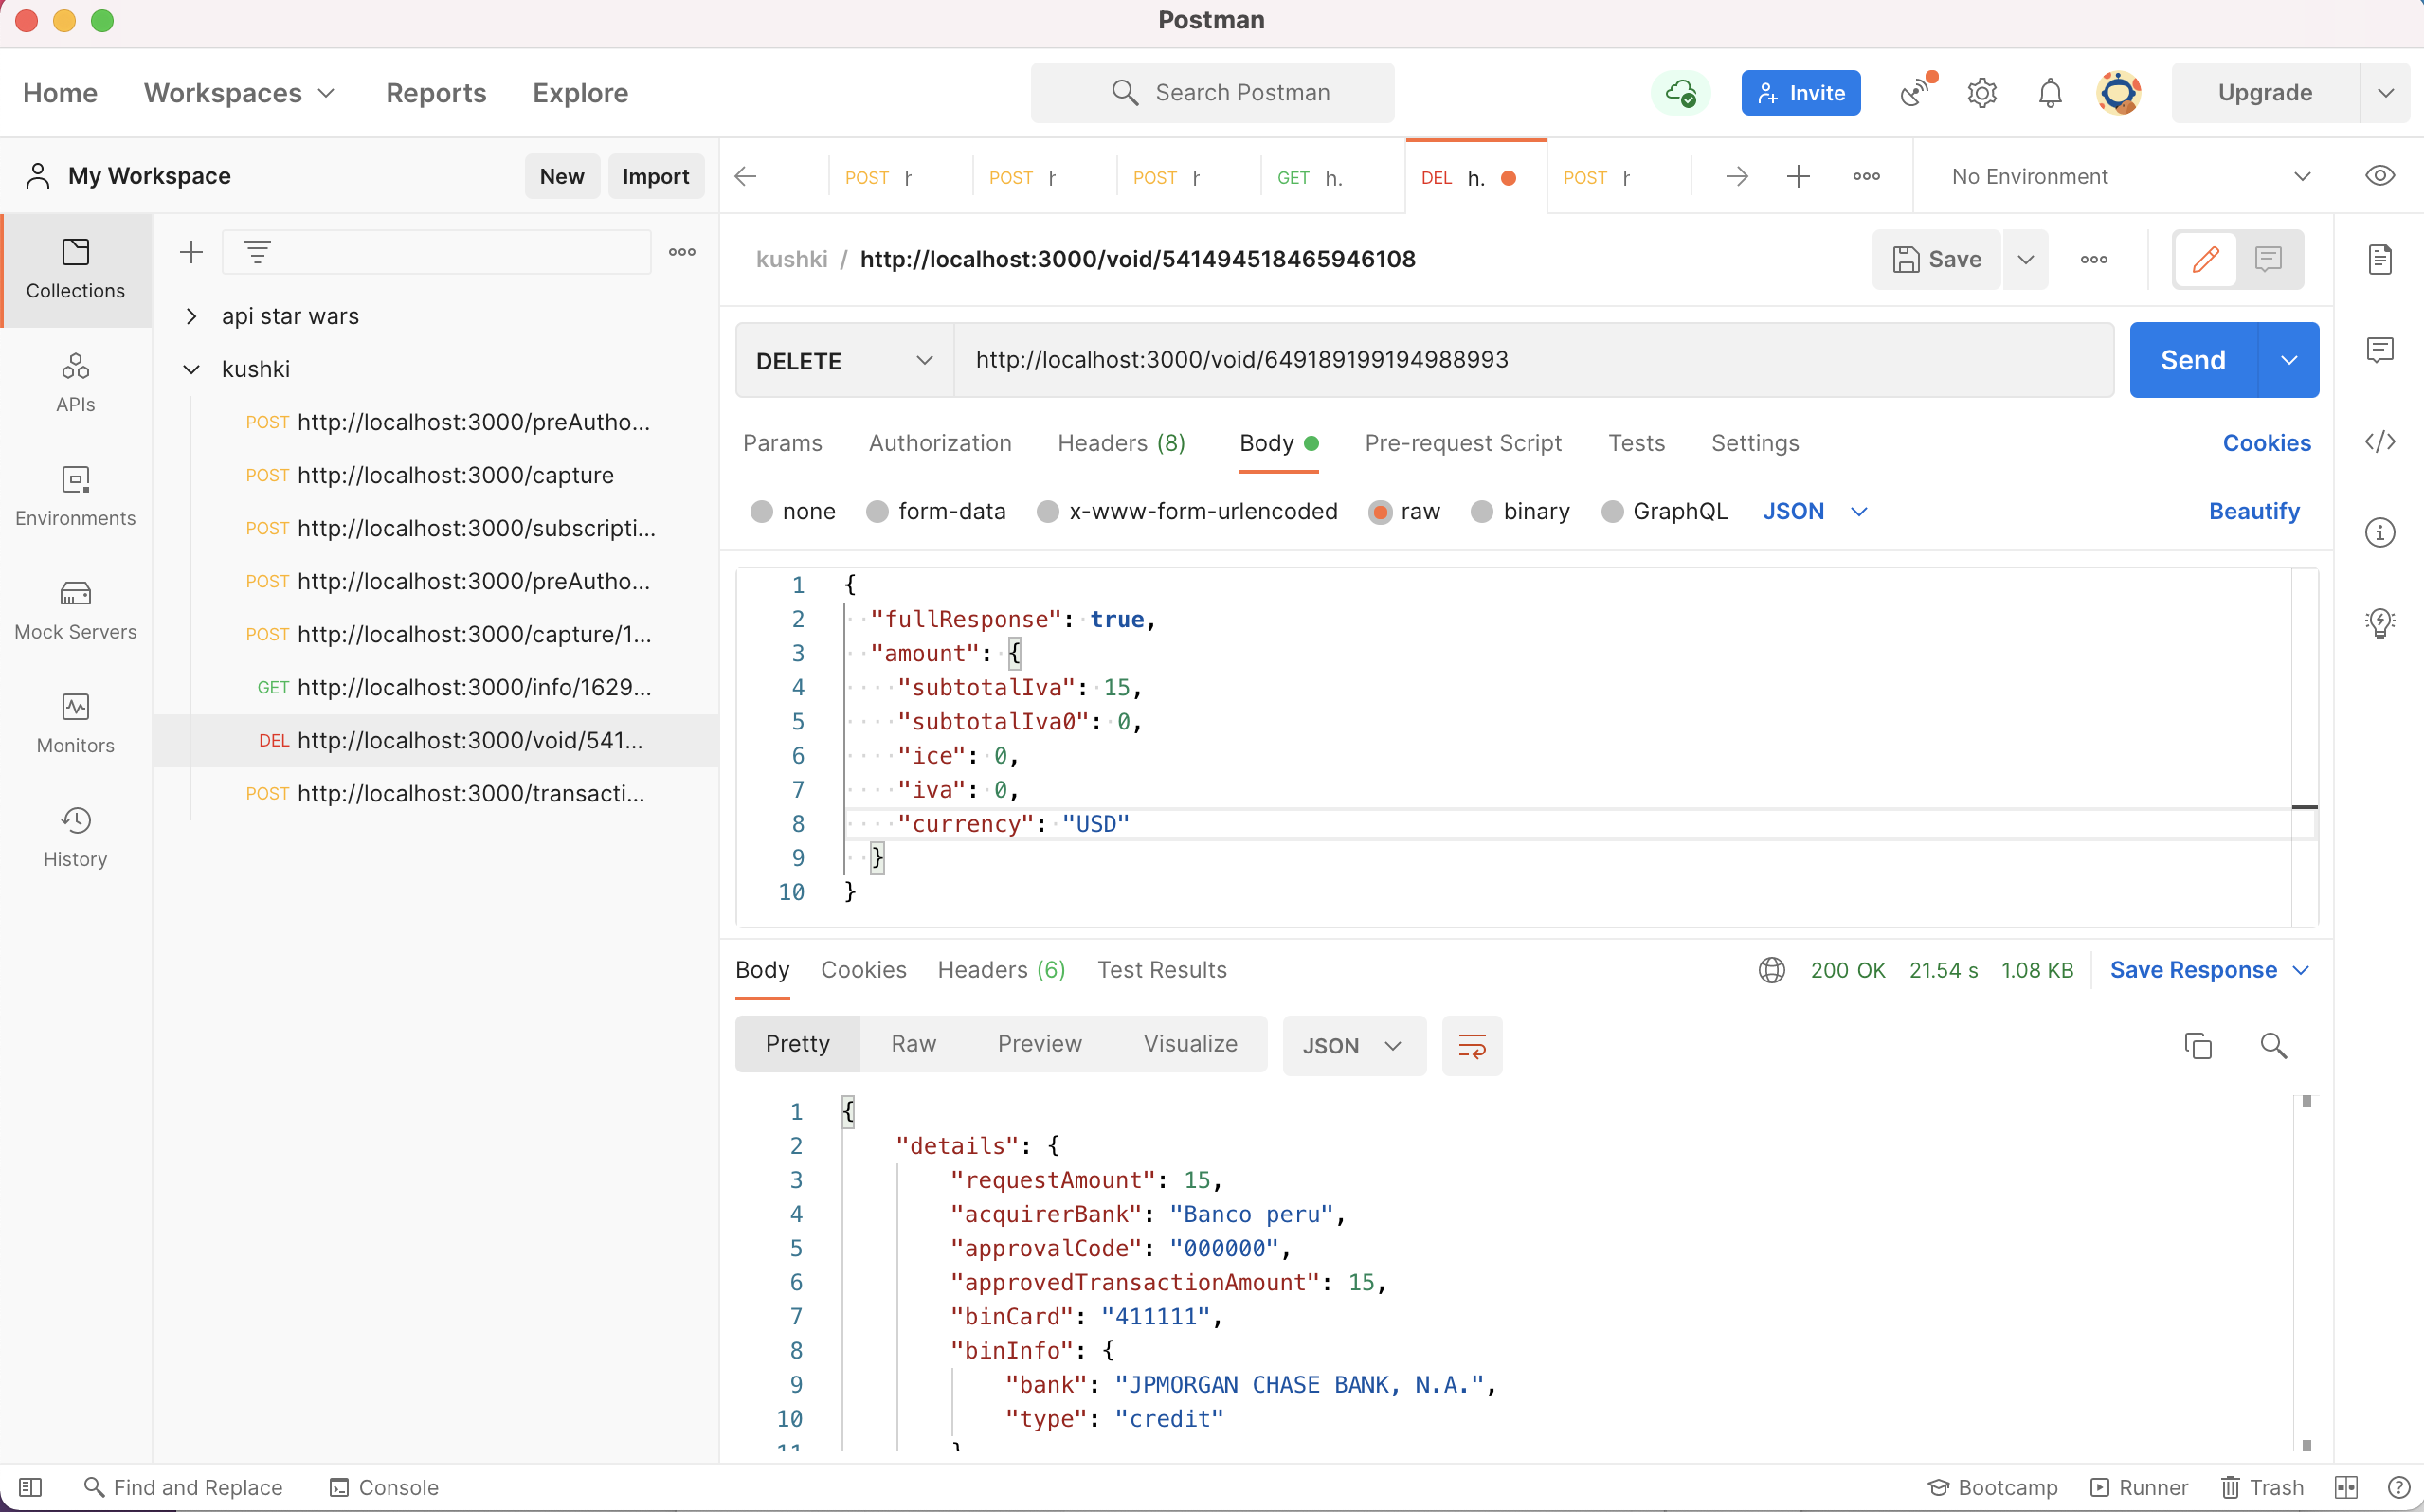

|  |  |
| --- | --- |
| **Tipo** | **Descripción** |
| URL | http://localhost:3000/void/649189199194988993 |
| Tipo | REST |
| Método | DELETE |
| Request | {  "fullResponse": **true**,  "amount": {  "subtotalIva": 15,  "subtotalIva0": 0,  "ice": 0,  "iva": 0,  "currency": "USD"  }  } |
| Response | {  "details": {  "requestAmount": 15,  "acquirerBank": "Banco peru",  "approvalCode": "000000",  "approvedTransactionAmount": 15,  "binCard": "411111",  "binInfo": {  "bank": "JPMORGAN CHASE BANK, N.A.",  "type": "credit"  },  "cardHolderName": "Manuel Torres",  "created": 1629907064858,  "currencyCode": "USD",  "fullResponse": **true**,  "iceValue": 0,  "ivaValue": 0,  "lastFourDigits": "1111",  "merchantId": "20000000104964980000",  "merchantName": "maserrot",  "paymentBrand": "VISA",  "processorBankName": "0032~BANCO INTERNACIONAL",  "processorId": "1000000926692173820216298348342",  "processorName": "Datafast Processor",  "responseCode": "000",  "subtotalIva": 0,  "subtotalIva0": 15,  "syncMode": "online",  "transactionId": "1629908386729703577",  "transactionReference": "55513951-5f93-4e4b-8892-f2a0848d37d4",  "transactionStatus": "INITIALIZED",  "transactionType": "VOID"  },  "ticketNumber": "661629908386730750",  "transactionReference": "55513951-5f93-4e4b-8892-f2a0848d37d4"  } |

## Get Transactions List

Para lo cual se implemento el back-end con nodeJs y express, para consumir el servicio se lo realizo por postman y se obtiene los siguientes resultados.

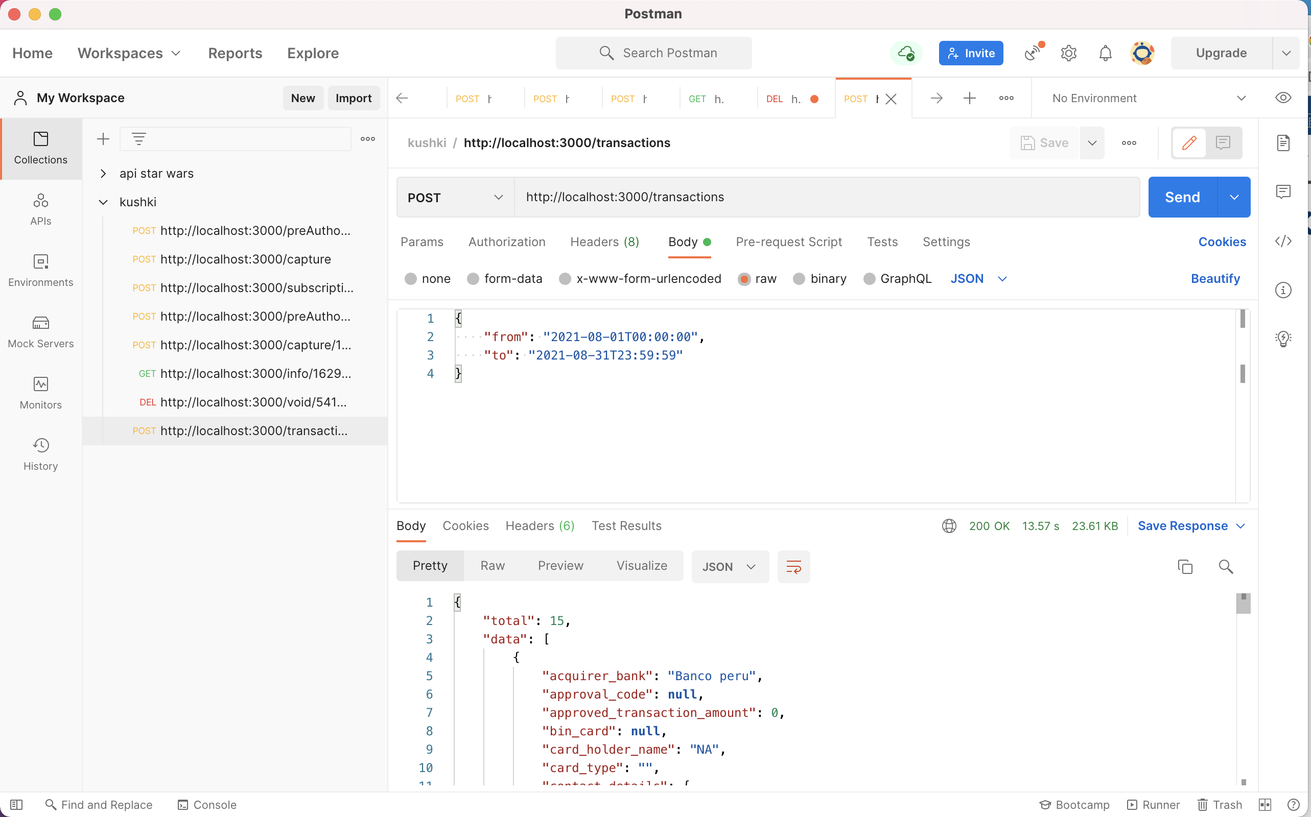

|  |  |
| --- | --- |
| **Tipo** | **Descripción** |
| URL | http://localhost:3000/transactions |
| Tipo | REST |
| Método | POST |
| Request | {  "from": "2021-08-01T00:00:00",  "to": "2021-08-31T23:59:59"  } |
| Response | {  "total": 15,  "data": [  {  "acquirer_bank": "Banco peru",  "approval_code": **null**,  "approved_transaction_amount": 0,  "bin_card": **null**,  "card_holder_name": "NA",  "card_type": "",  "contact_details": {  "document_number": "1009283738",  "document_type": "CC",  "email": "test@test.com",  "first_name": "Diego",  "last_name": "Cadena",  "phone_number": "+5730162826289"  },  "country": "Peru",  "created": "2021-08-24T23:32:37.000Z",  "credential_alias": "maserrot",  "credential_id": "2f7d52ef878c44039c03f54e079e6ffd",  "currency_code": "USD",  "foreign_card": **true**,  "ice_value": 0,  "issuing_bank": **null**,  "iva_value": 0,  "last_four_digits": **null**,  "merchant_id": "20000000104964980000",  "merchant_name": "maserrot",  "metadata": {  "contractID": "157AB"  },  "payment_brand": "",  "processor": {  "code": "K006",  "message": "Transacción declinada."  },  "processor_id": "1000000926692173820216298348342",  "processor_name": **null**,  "processor_type": "gateway",  "request_amount": 15,  "response_code": "577",  "response_text": "El token de la transacción no es válido",  "subtotal_iva": 0,  "subtotal_iva0": 15,  "sync_mode": "online",  "transaction_id": "971480464692021011",  "transaction_reference": "d8374b2d-d485-4c87-bc75-0f762c9de69f",  "transaction_status": "DECLINED",  "transaction_type": "SALE",  "payment_method": "card",  "masked_credit_card": "XXXXXXXXXXXXXXXX",  "security": {  "ip": **null**  },  "string_metadata": "{\"contractID\":\"157AB\"}",  "order_details": {  "shipping_details": {  "country": "Colombia",  "zip_code": "170402",  "address": "Eloy Alfaro 139 y Catalina Aldaz",  "phone": "+5730162826289",  "city": "Medellín",  "name": "Diego Cadena",  "region": "Antioquia"  },  "billing_details": {  "country": "Colombia",  "zip_code": "170402",  "address": "Eloy Alfaro 139 y Catalina Aldaz",  "phone": "+593988734644",  "city": "Medellín",  "name": "Diego Osorio",  "region": "Antioquia"  },  "site_domain": "tuebook.com"  },  "product_details": {  "product": [  {  "quantity": 1,  "price": 69900,  "id": "198952AB",  "title": "eBook Digital Services",  "sku": "10101042"  },  {  "quantity": 1,  "price": 99900,  "id": "198953AB",  "title": "eBook Virtual Selling",  "sku": "004834GQ"  }  ]  }  },  {  "acquirer_bank": "Banco peru",  "approval_code": **null**,  "approved_transaction_amount": 0,  "bin_card": **null**,  "card_holder_name": "NA",  "card_type": "",  "contact_details": {  "document_number": "1009283738",  "document_type": "CC",  "email": "test@test.com",  "first_name": "Diego",  "last_name": "Cadena",  "phone_number": "+5730162826289"  },  "country": "Peru",  "created": "2021-08-24T23:33:08.000Z",  "credential_alias": "maserrot",  "credential_id": "2f7d52ef878c44039c03f54e079e6ffd",  "currency_code": "USD",  "foreign_card": **true**,  "ice_value": 0,  "issuing_bank": **null**,  "iva_value": 0,  "last_four_digits": **null**,  "merchant_id": "20000000104964980000",  "merchant_name": "maserrot",  "metadata": {  "contractID": "157AB"  },  "payment_brand": "",  "processor": {  "code": "K006",  "message": "Transacción declinada."  },  "processor_id": "1000000926692173820216298348342",  "processor_name": **null**,  "processor_type": "gateway",  "request_amount": 15,  "response_code": "577",  "response_text": "El token de la transacción no es válido",  "subtotal_iva": 0,  "subtotal_iva0": 15,  "sync_mode": "online",  "transaction_id": "952848471755599724",  "transaction_reference": "a8ff6d26-2a07-499f-956a-9794028f4df5",  "transaction_status": "DECLINED",  "transaction_type": "SALE",  "payment_method": "card",  "masked_credit_card": "XXXXXXXXXXXXXXXX",  "security": {  "ip": **null**  },  "string_metadata": "{\"contractID\":\"157AB\"}",  "order_details": {  "shipping_details": {  "country": "Colombia",  "zip_code": "170402",  "address": "Eloy Alfaro 139 y Catalina Aldaz",  "phone": "+5730162826289",  "city": "Medellín",  "name": "Diego Cadena",  "region": "Antioquia"  },  "billing_details": {  "country": "Colombia",  "zip_code": "170402",  "address": "Eloy Alfaro 139 y Catalina Aldaz",  "phone": "+593988734644",  "city": "Medellín",  "name": "Diego Osorio",  "region": "Antioquia"  },  "site_domain": "tuebook.com"  },  "product_details": {  "product": [  {  "quantity": 1,  "price": 69900,  "id": "198952AB",  "title": "eBook Digital Services",  "sku": "10101042"  },  {  "quantity": 1,  "price": 99900,  "id": "198953AB",  "title": "eBook Virtual Selling",  "sku": "004834GQ"  }  ]  }  },  {  "acquirer_bank": "Banco peru",  "approval_code": **null**,  "approved_transaction_amount": 0,  "bin_card": **null**,  "card_holder_name": "NA",  "card_type": "",  "contact_details": {  "document_number": "1009283738",  "document_type": "CC",  "email": "test@test.com",  "first_name": "Diego",  "last_name": "Cadena",  "phone_number": "+5730162826289"  },  "country": "Peru",  "created": "2021-08-24T23:37:39.000Z",  "credential_alias": "maserrot",  "credential_id": "2f7d52ef878c44039c03f54e079e6ffd",  "currency_code": "USD",  "foreign_card": **true**,  "ice_value": 0,  "issuing_bank": **null**,  "iva_value": 0,  "last_four_digits": **null**,  "merchant_id": "20000000104964980000",  "merchant_name": "maserrot",  "metadata": {  "contractID": "157AB"  },  "payment_brand": "",  "processor": {  "code": "K006",  "message": "Transacción declinada."  },  "processor_id": "1000000926692173820216298348342",  "processor_name": **null**,  "processor_type": "gateway",  "request_amount": 15,  "response_code": "577",  "response_text": "El token de la transacción no es válido",  "subtotal_iva": 0,  "subtotal_iva0": 15,  "sync_mode": "online",  "transaction_id": "672208053429768519",  "transaction_reference": "a5515fd4-f574-4605-9525-34f1fdd6f9b1",  "transaction_status": "DECLINED",  "transaction_type": "SALE",  "payment_method": "card",  "masked_credit_card": "XXXXXXXXXXXXXXXX",  "security": {  "ip": **null**  },  "string_metadata": "{\"contractID\":\"157AB\"}",  "order_details": {  "shipping_details": {  "country": "Colombia",  "zip_code": "170402",  "address": "Eloy Alfaro 139 y Catalina Aldaz",  "phone": "+5730162826289",  "city": "Medellín",  "name": "Diego Cadena",  "region": "Antioquia"  },  "billing_details": {  "country": "Colombia",  "zip_code": "170402",  "address": "Eloy Alfaro 139 y Catalina Aldaz",  "phone": "+593988734644",  "city": "Medellín",  "name": "Diego Osorio",  "region": "Antioquia"  },  "site_domain": "tuebook.com"  },  "product_details": {  "product": [  {  "quantity": 1,  "price": 69900,  "id": "198952AB",  "title": "eBook Digital Services",  "sku": "10101042"  },  {  "quantity": 1,  "price": 99900,  "id": "198953AB",  "title": "eBook Virtual Selling",  "sku": "004834GQ"  }  ]  }  },  {  "acquirer_bank": "Banco peru",  "approval_code": **null**,  "approved_transaction_amount": 0,  "bin_card": **null**,  "card_holder_name": "NA",  "card_type": "",  "country": "Peru",  "created": "2021-08-24T23:47:06.000Z",  "credential_alias": "maserrot",  "credential_id": "2f7d52ef878c44039c03f54e079e6ffd",  "currency_code": "PEN",  "foreign_card": **true**,  "ice_value": 0,  "issuing_bank": **null**,  "iva_value": 0,  "last_four_digits": **null**,  "merchant_id": "20000000104964980000",  "merchant_name": "maserrot",  "payment_brand": "",  "processor": {  "code": "K006",  "message": "Transacción declinada."  },  "processor_id": "1000000926692173820216298348342",  "processor_name": **null**,  "processor_type": "gateway",  "request_amount": 600,  "response_code": "577",  "response_text": "El token de la transacción no es válido",  "subtotal_iva": 0,  "subtotal_iva0": 600,  "sync_mode": "online",  "transaction_id": "821338121279254664",  "transaction_reference": "9d2bb7b7-d8b0-4bd8-8af5-dd7295f0c628",  "transaction_status": "DECLINED",  "transaction_type": "PREAUTHORIZATION",  "payment_method": "card",  "masked_credit_card": "XXXXXXXXXXXXXXXX",  "security": {  "ip": **null**  }  },  {  "acquirer_bank": "Banco peru",  "approval_code": **null**,  "approved_transaction_amount": 0,  "bin_card": **null**,  "card_holder_name": "NA",  "card_type": "",  "country": "Peru",  "created": "2021-08-24T23:48:58.000Z",  "credential_alias": "maserrot",  "credential_id": "2f7d52ef878c44039c03f54e079e6ffd",  "currency_code": "PEN",  "foreign_card": **true**,  "ice_value": 0,  "issuing_bank": **null**,  "iva_value": 0,  "last_four_digits": **null**,  "merchant_id": "20000000104964980000",  "merchant_name": "maserrot",  "payment_brand": "",  "processor": {  "code": "K006",  "message": "Transacción declinada."  },  "processor_id": "1000000926692173820216298348342",  "processor_name": **null**,  "processor_type": "gateway",  "request_amount": 600,  "response_code": "577",  "response_text": "El token de la transacción no es válido",  "subtotal_iva": 0,  "subtotal_iva0": 600,  "sync_mode": "online",  "transaction_id": "995720188160081752",  "transaction_reference": "051edff2-3078-4763-b1f7-9207814bba74",  "transaction_status": "DECLINED",  "transaction_type": "PREAUTHORIZATION",  "payment_method": "card",  "masked_credit_card": "XXXXXXXXXXXXXXXX",  "security": {  "ip": **null**  }  },  {  "acquirer_bank": "Banco peru",  "approval_code": **null**,  "approved_transaction_amount": 0,  "bin_card": **null**,  "card_holder_name": "NA",  "card_type": "",  "country": "Peru",  "created": "2021-08-24T23:50:16.000Z",  "credential_alias": "maserrot",  "credential_id": "2f7d52ef878c44039c03f54e079e6ffd",  "currency_code": "PEN",  "foreign_card": **true**,  "ice_value": 0,  "issuing_bank": **null**,  "iva_value": 0,  "last_four_digits": **null**,  "merchant_id": "20000000104964980000",  "merchant_name": "maserrot",  "payment_brand": "",  "processor": {  "code": "K006",  "message": "Transacción declinada."  },  "processor_id": "1000000926692173820216298348342",  "processor_name": **null**,  "processor_type": "gateway",  "request_amount": 600,  "response_code": "577",  "response_text": "El token de la transacción no es válido",  "subtotal_iva": 0,  "subtotal_iva0": 600,  "sync_mode": "online",  "transaction_id": "939804579689524992",  "transaction_reference": "dd14e11a-ca4e-4354-98d9-46d3b2a711ec",  "transaction_status": "DECLINED",  "transaction_type": "PREAUTHORIZATION",  "payment_method": "card",  "masked_credit_card": "XXXXXXXXXXXXXXXX",  "security": {  "ip": **null**  }  },  {  "acquirer_bank": "Banco peru",  "approval_code": "000000",  "approved_transaction_amount": 15,  "bin_card": "411111",  "card_holder_name": "NA",  "card_type": "",  "country": "Peru",  "created": "2021-08-24T23:53:22.000Z",  "credential_alias": "maserrot",  "credential_id": "2f7d52ef878c44039c03f54e079e6ffd",  "credit_type": **null**,  "currency_code": "USD",  "foreign_card": **true**,  "ice_value": 0,  "issuing_bank": **null**,  "iva_value": 0,  "last_four_digits": "1111",  "merchant_id": "20000000104964980000",  "merchant_name": "maserrot",  "payment_brand": "Visa",  "processor_id": "1000000926692173820216298348342",  "processor_name": "Credimatic Processor",  "processor_type": "gateway",  "request_amount": 15,  "response_code": "000",  "response_text": "Transacción aprobada",  "subtotal_iva": 0,  "subtotal_iva0": 15,  "sync_mode": "online",  "ticket_number": "935323410355610540",  "transaction_id": "804479611234089106",  "transaction_reference": "b7eba4c5-577c-43fb-b9e3-6c33053c7883",  "transaction_status": "APPROVAL",  "transaction_type": "PREAUTHORIZATION",  "card_country_code": "US",  "card_country": "United States of America",  "payment_method": "card",  "masked_credit_card": "411111XXXXXX1111",  "security": {  "ip": **null**,  "user_agent": **null**,  "whitelist": **false**  }  },  {  "acquirer_bank": "Banco peru",  "approval_code": "000000",  "approved_transaction_amount": 15,  "bin_card": "411111",  "card_holder_name": "NA",  "card_type": "",  "country": "Peru",  "created": "2021-08-25T01:03:17.000Z",  "credential_alias": "maserrot",  "credential_id": "2f7d52ef878c44039c03f54e079e6ffd",  "currency_code": "USD",  "foreign_card": **true**,  "ice_value": 0,  "issuing_bank": **null**,  "iva_value": 0,  "last_four_digits": "1111",  "merchant_id": "20000000104964980000",  "merchant_name": "maserrot",  "payment_brand": "Visa",  "preauth_transaction_reference": "c3c3b9d3-8ae6-49db-b1f8-554ea6741a91",  "processor_id": "1000000926692173820216298348342",  "processor_name": "Credimatic Processor",  "processor_type": "gateway",  "request_amount": 15,  "response_code": "000",  "response_text": "Transacción aprobada",  "subtotal_iva": 0,  "subtotal_iva0": 15,  "sync_mode": "online",  "ticket_number": "903099390755146450",  "transaction_id": "619219249875504922",  "transaction_reference": "c3c3b9d3-8ae6-49db-b1f8-554ea6741a91",  "transaction_status": "APPROVAL",  "transaction_type": "CAPTURE",  "card_country_code": "US",  "card_country": "United States of America",  "payment_method": "card",  "masked_credit_card": "411111XXXXXX1111",  "security": {}  },  {  "acquirer_bank": "Banco peru",  "approval_code": **null**,  "approved_transaction_amount": 0,  "bin_card": "411111",  "card_holder_name": "Manuel Torres",  "card_type": "Credit",  "contact_details": {  "document_number": "1009283738",  "document_type": "CC",  "email": "test@test.com",  "first_name": "Diego",  "last_name": "Cadena",  "phone_number": "+593988734644"  },  "country": "Peru",  "created": "2021-08-25T02:15:34.194Z",  "credential_alias": "maserrot",  "credential_id": "2f7d52ef878c44039c03f54e079e6ffd",  "currency_code": "PEN",  "foreign_card": **true**,  "ice_value": 0,  "issuing_bank": "JPMORGAN CHASE BANK, N.A.",  "iva_value": 0,  "last_four_digits": "1111",  "merchant_id": "20000000104964980000",  "merchant_name": "maserrot",  "metadata": {},  "payment_brand": "Visa",  "processor_id": "1000000926692173820216298348342",  "processor_name": "Credimatic Processor",  "processor_type": "gateway",  "provider": "kushki",  "request_amount": 600,  "response_code": "205",  "response_text": "Tipo de moneda no válida",  "subscription_id": "1629857422039000",  "subscription_metadata": {  "plan": {  "fitness": {  "rumba": "include",  "pool": "include",  "cardio": "include"  }  }  },  "subscription_trigger": "onDemand",  "subtotal_iva": 0,  "subtotal_iva0": 600,  "transaction_id": "917135592118900495",  "transaction_reference": "1e46a4be-7d06-4bec-be16-284989895377",  "transaction_status": "DECLINED",  "transaction_type": "SALE",  "payment_method": "card",  "masked_credit_card": "411111XXXXXX1111",  "security": {  "ip": "186.69.173.140",  "user_agent": "Mozilla/5.0 (Macintosh; Intel Mac OS X 10_15_7) AppleWebKit/537.36 (KHTML, like Gecko) Chrome/92.0.4515.159 Safari/537.36",  "whitelist": **false**  },  "card_country_code": "US",  "card_country": "United States of America",  "string_metadata": "{}"  },  {  "acquirer_bank": "Banco peru",  "approval_code": "000000",  "approved_transaction_amount": 15,  "bin_card": "411111",  "card_holder_name": "Manuel Torres",  "card_type": "Credit",  "contact_details": {  "document_number": "1009283738",  "document_type": "CC",  "email": "test@test.com",  "first_name": "Diego",  "last_name": "Cadena",  "phone_number": "+593988734644"  },  "country": "Peru",  "created": "2021-08-25T02:15:57.976Z",  "credential_alias": "maserrot",  "credential_id": "2f7d52ef878c44039c03f54e079e6ffd",  "currency_code": "USD",  "foreign_card": **true**,  "ice_value": 0,  "issuing_bank": "JPMORGAN CHASE BANK, N.A.",  "iva_value": 0,  "last_four_digits": "1111",  "merchant_id": "20000000104964980000",  "merchant_name": "maserrot",  "metadata": {},  "payment_brand": "Visa",  "processor_id": "1000000926692173820216298348342",  "processor_name": "Credimatic Processor",  "processor_type": "gateway",  "provider": "kushki",  "request_amount": 15,  "response_code": "000",  "response_text": "Transacción aprobada",  "subscription_id": "1629857422039000",  "subscription_metadata": {  "plan": {  "fitness": {  "rumba": "include",  "pool": "include",  "cardio": "include"  }  }  },  "subscription_trigger": "onDemand",  "subtotal_iva": 0,  "subtotal_iva0": 15,  "ticket_number": "541494518465946108",  "transaction_id": "028191397710972631",  "transaction_reference": "94fe05cb-de66-4da1-8383-705ac18626f9",  "transaction_status": "APPROVAL",  "transaction_type": "PREAUTHORIZATION",  "payment_method": "card",  "masked_credit_card": "411111XXXXXX1111",  "security": {  "ip": "186.69.173.140",  "user_agent": "Mozilla/5.0 (Macintosh; Intel Mac OS X 10_15_7) AppleWebKit/537.36 (KHTML, like Gecko) Chrome/92.0.4515.159 Safari/537.36",  "whitelist": **false**  },  "card_country_code": "US",  "card_country": "United States of America",  "string_metadata": "{}"  },  {  "acquirer_bank": "Banco peru",  "approval_code": "000000",  "approved_transaction_amount": 15,  "bin_card": "411111",  "card_holder_name": "Manuel Torres",  "card_type": "Credit",  "contact_details": {  "document_number": "1009283738",  "document_type": "CC",  "email": "test@test.com",  "first_name": "Diego",  "last_name": "Cadena",  "phone_number": "+593988734644"  },  "country": "Peru",  "created": "2021-08-25T02:19:53.683Z",  "credential_alias": "maserrot",  "credential_id": "2f7d52ef878c44039c03f54e079e6ffd",  "currency_code": "USD",  "foreign_card": **true**,  "ice_value": 0,  "issuing_bank": "JPMORGAN CHASE BANK, N.A.",  "iva_value": 0,  "last_four_digits": "1111",  "merchant_id": "20000000104964980000",  "merchant_name": "maserrot",  "metadata": {},  "payment_brand": "Visa",  "preauth_transaction_reference": "94fe05cb-de66-4da1-8383-705ac18626f9",  "processor_id": "1000000926692173820216298348342",  "processor_name": "Credimatic Processor",  "processor_type": "gateway",  "provider": "kushki",  "request_amount": 15,  "response_code": "000",  "response_text": "Transacción aprobada",  "subscription_id": "1629857422039000",  "subscription_metadata": {  "plan": {  "fitness": {  "rumba": "include",  "pool": "include",  "cardio": "include"  }  }  },  "subscription_trigger": "onDemand",  "subtotal_iva": 0,  "subtotal_iva0": 15,  "ticket_number": "525408235295159784",  "transaction_id": "344648170742286276",  "transaction_reference": "aa721a56-e022-4d2e-8ed7-9dea4b738d61",  "transaction_status": "APPROVAL",  "transaction_type": "CAPTURE",  "payment_method": "card",  "masked_credit_card": "411111XXXXXX1111",  "security": {  "ip": "186.69.173.140",  "user_agent": "Mozilla/5.0 (Macintosh; Intel Mac OS X 10_15_7) AppleWebKit/537.36 (KHTML, like Gecko) Chrome/92.0.4515.159 Safari/537.36",  "whitelist": **false**  },  "card_country_code": "US",  "card_country": "United States of America",  "string_metadata": "{}"  },  {  "approved_transaction_amount": 15,  "aurus_ticket_number": "541494518465946108",  "bin_card": "411111",  "card_holder_name": "Manuel Torres",  "card_type": "Credit",  "contact_person": "Manuel Torres",  "country": "Peru",  "created": "2021-08-25T02:37:56.179Z",  "currency_code": "USD",  "email": "maserrot@hotmail.com",  "foreign_card": **true**,  "historical": [  {  "approval_code": "000000",  "approved_transaction_amount": 15,  "bin_card": "411111",  "card_holder_name": "Manuel Torres",  "card_type": "Credit",  "contact_person": "Manuel Torres",  "country": "Peru",  "created": "2021-08-25T02:37:45.390Z",  "currency_code": "USD",  "email": "maserrot@hotmail.com",  "foreign_card": **true**,  "ice_value": 0,  "iva_value": 0,  "last_four_digits": "1111",  "masked_credit_card": "411111XXXXXX1111",  "merchant_id": "20000000104964980000",  "merchant_name": "maserrot",  "nit": "1234567890",  "payment_brand": "Visa",  "payment_method": "card",  "processor_bank_name": "0032~BANCO INTERNACIONAL",  "processor_id": "1000000926692173820216298348342",  "processor_merchant_id": "543210",  "processor_name": "Credimatic Processor",  "processor_private_id": "1000000926692314849016298348342",  "processor_type": "gateway",  "request_amount": 15,  "response_code": "000",  "response_text": "Transacción aprobada",  "sale_approval_code": "000000",  "sale_ticket_number": "541494518465946108",  "subscription_id": "1629857422039000",  "subscription_trigger": "onDemand",  "subtotal_iva": 0,  "subtotal_iva0": 15,  "sync_mode": "online",  "terminal_id": **null**,  "ticket_number": "661629859065287536",  "transaction_id": "1629859065286596265",  "transaction_reference": "94fe05cb-de66-4da1-8383-705ac18626f9",  "transaction_status": "INITIALIZED",  "transaction_type": "VOID",  "visibility": "visible"  }  ],  "ice_value": 0,  "iva_value": 0,  "last_four_digits": "1111",  "masked_credit_card": "411111XXXXXX1111",  "merchant_id": "20000000104964980000",  "merchant_name": "maserrot",  "metadata": {},  "nit": "1234567890",  "payment_brand": "Visa",  "payment_method": "card",  "processor_id": "1000000926692173820216298348342",  "processor_merchant_id": "543210",  "processor_name": "Credimatic Processor",  "processor_private_id": "1000000926692314849016298348342",  "processor_type": "gateway",  "request_amount": 15,  "response_code": "000",  "response_text": "Transacción aprobada",  "sale_approval_code": "000000",  "sale_ticket_number": "541494518465946108",  "subscription_id": "1629857422039000",  "subscription_metadata": {  "plan": {  "fitness": {  "rumba": "include",  "pool": "include",  "cardio": "include"  }  }  },  "subscription_trigger": "onDemand",  "subtotal_iva": 0,  "subtotal_iva0": 15,  "sync_mode": "online",  "terminal_id": **null**,  "ticket_number": "661629859065287536",  "transaction_id": "028191397710972631",  "transaction_reference": "8c89fd14-14c8-4a65-9c04-c746a01c9090",  "transaction_status": "APPROVAL",  "transaction_type": "VOID",  "visibility": "visible",  "void_ticket_number": "661629859065287536"  },  {  "acquirer_bank": "Banco peru",  "approval_code": "000000",  "approved_transaction_amount": 15,  "bin_card": "411111",  "card_holder_name": "Manuel Torres",  "card_type": "Credit",  "contact_details": {  "document_number": "1009283738",  "document_type": "CC",  "email": "test@test.com",  "first_name": "Diego",  "last_name": "Cadena",  "phone_number": "+593988734644"  },  "country": "Peru",  "created": "2021-08-25T15:57:44.858Z",  "credential_alias": "maserrot",  "credential_id": "2f7d52ef878c44039c03f54e079e6ffd",  "currency_code": "USD",  "foreign_card": **true**,  "ice_value": 0,  "issuing_bank": "JPMORGAN CHASE BANK, N.A.",  "iva_value": 0,  "last_four_digits": "1111",  "merchant_id": "20000000104964980000",  "merchant_name": "maserrot",  "metadata": {},  "payment_brand": "Visa",  "processor_id": "1000000926692173820216298348342",  "processor_name": "Datafast Processor",  "processor_type": "gateway",  "provider": "kushki",  "request_amount": 15,  "response_code": "000",  "response_text": "Transacción aprobada",  "subscription_id": "1629906697211000",  "subscription_metadata": {  "plan": {  "fitness": {  "rumba": "include",  "pool": "include",  "cardio": "include"  }  }  },  "subscription_trigger": "onDemand",  "subtotal_iva": 0,  "subtotal_iva0": 15,  "ticket_number": "649189199194988993",  "transaction_id": "464083956044158961",  "transaction_reference": "55513951-5f93-4e4b-8892-f2a0848d37d4",  "transaction_status": "APPROVAL",  "transaction_type": "PREAUTHORIZATION",  "payment_method": "card",  "masked_credit_card": "411111XXXXXX1111",  "security": {  "ip": "186.69.173.140",  "user_agent": "Mozilla/5.0 (Macintosh; Intel Mac OS X 10_15_7) AppleWebKit/537.36 (KHTML, like Gecko) Chrome/92.0.4515.159 Safari/537.36",  "whitelist": **false**  },  "card_country_code": "US",  "card_country": "United States of America",  "string_metadata": "{}"  },  {  "acquirer_bank": "Banco peru",  "approval_code": "000000",  "approved_transaction_amount": 15,  "bin_card": "411111",  "card_holder_name": "Manuel Torres",  "card_type": "Credit",  "contact_details": {  "document_number": "1009283738",  "document_type": "CC",  "email": "test@test.com",  "first_name": "Diego",  "last_name": "Cadena",  "phone_number": "+593988734644"  },  "country": "Peru",  "created": "2021-08-25T16:08:59.447Z",  "credential_alias": "maserrot",  "credential_id": "2f7d52ef878c44039c03f54e079e6ffd",  "currency_code": "USD",  "foreign_card": **true**,  "ice_value": 0,  "issuing_bank": "JPMORGAN CHASE BANK, N.A.",  "iva_value": 0,  "last_four_digits": "1111",  "merchant_id": "20000000104964980000",  "merchant_name": "maserrot",  "metadata": {},  "payment_brand": "Visa",  "preauth_transaction_reference": "55513951-5f93-4e4b-8892-f2a0848d37d4",  "processor_id": "1000000926692173820216298348342",  "processor_name": "Datafast Processor",  "processor_type": "gateway",  "provider": "kushki",  "request_amount": 15,  "response_code": "000",  "response_text": "Transacción aprobada",  "subscription_id": "1629906697211000",  "subscription_metadata": {  "plan": {  "fitness": {  "rumba": "include",  "pool": "include",  "cardio": "include"  }  }  },  "subscription_trigger": "onDemand",  "subtotal_iva": 0,  "subtotal_iva0": 15,  "ticket_number": "039945700471024985",  "transaction_id": "186883766161297715",  "transaction_reference": "713de06b-9820-4398-a9bd-78e39a1e94c6",  "transaction_status": "APPROVAL",  "transaction_type": "CAPTURE",  "payment_method": "card",  "masked_credit_card": "411111XXXXXX1111",  "security": {  "ip": "186.69.173.140",  "user_agent": "Mozilla/5.0 (Macintosh; Intel Mac OS X 10_15_7) AppleWebKit/537.36 (KHTML, like Gecko) Chrome/92.0.4515.159 Safari/537.36",  "whitelist": **false**  },  "card_country_code": "US",  "card_country": "United States of America",  "string_metadata": "{}"  },  {  "ice_value": 0,  "iva_value": 0,  "subtotal_iva": 0,  "subtotal_iva0": 15,  "approval_code": "000000",  "approved_transaction_amount": 15,  "bin_card": "411111",  "card_holder_name": "Manuel Torres",  "card_type": "Credit",  "contact_person": "Manuel Torres",  "country": "Peru",  "created": "2021-08-25T16:19:46.834Z",  "currency_code": "USD",  "email": "maserrot@hotmail.com",  "foreign_card": **true**,  "last_four_digits": "1111",  "merchant_id": "20000000104964980000",  "merchant_name": "maserrot",  "metadata": {},  "nit": "1234567890",  "payment_brand": "Visa",  "processor_bank_name": "0032~BANCO INTERNACIONAL",  "processor_id": "1000000926692173820216298348342",  "processor_merchant_id": "543210",  "processor_name": "Datafast Processor",  "processor_private_id": "1000000926692314849016298348342",  "processor_type": "gateway",  "request_amount": 15,  "response_code": "000",  "response_text": "Transacción aprobada",  "sale_approval_code": "000000",  "sale_ticket_number": "649189199194988993",  "subscription_id": "1629906697211000",  "subscription_metadata": {  "plan": {  "fitness": {  "rumba": "include",  "pool": "include",  "cardio": "include"  }  }  },  "subscription_trigger": "onDemand",  "sync_mode": "online",  "terminal_id": **null**,  "ticket_number": "661629908386730750",  "transaction_id": "1629908386729703577",  "transaction_reference": "55513951-5f93-4e4b-8892-f2a0848d37d4",  "transaction_status": "INITIALIZED",  "transaction_type": "VOID",  "visibility": "visible",  "payment_method": "card",  "masked_credit_card": "411111XXXXXX1111"  }  ]  } |

## Experiencia de Onboarding con Kushki, Oportunidades de mejoras identificadas.

He implementado kushki con algunos clientes, tambien poseo experiencia implementando botones de pago de otros proveedores, la implantacion de kushki no ha tenido mayores problemas, los problemas que tuve fueron con los SDK de IOS y android pero fueorn solicionados oportunamente.

## Experiencia con la documentacion técnica, Oportunidades de mejoras identificadas y propuestas de mejora de las mismas.

La documentación es clara, consisa no veo oportunidades de mejora en ese sentido

## Que entiendes por el concepto de tokenización y por qué cree que se recomienda tokenizar por medio de una solución front-end.

La tokenización es el proceso en el cual los datos ingresados por el cliente se convierten en un token sean estos por ejemplo la tarjeta de credito, con eso el front-end no sabe cual es la tarjeta que ingreso el cliente, solo conoce el token. Esto hace que las transacciones sean mas seguras. Y se recomienda tokenizar por la seguridad que brinda no conocer los datos ingresados en el cajita de pagos por ejemplo solo se conoce el token de la transaccion.

## Que entiendes por el concepto de webhook y cual es su utilidad.

Los webhook son acciones que sirven para desencadenar otras acciones, esto puede ser de utilidad ya que por ejemplo queremos actualizar el stock en linea de una un producto, pues cuando se haga la llamada al metodo para que actualice la información este dispare una o mas acciones por ejemplo informale al encargado que dicho producto ya esta por acabar su stock. En los bancos se podria decir que si retiras dinero este informe a todos para que se actualice tu saldo, etc.

# Consideraciones

No hay consideraciones a tomar.